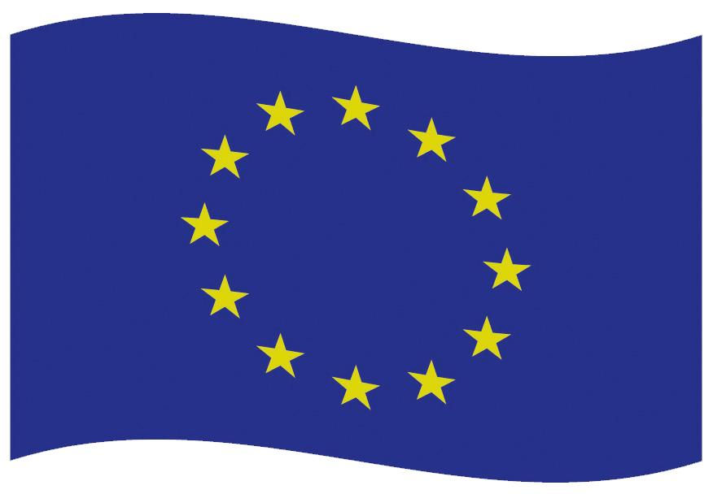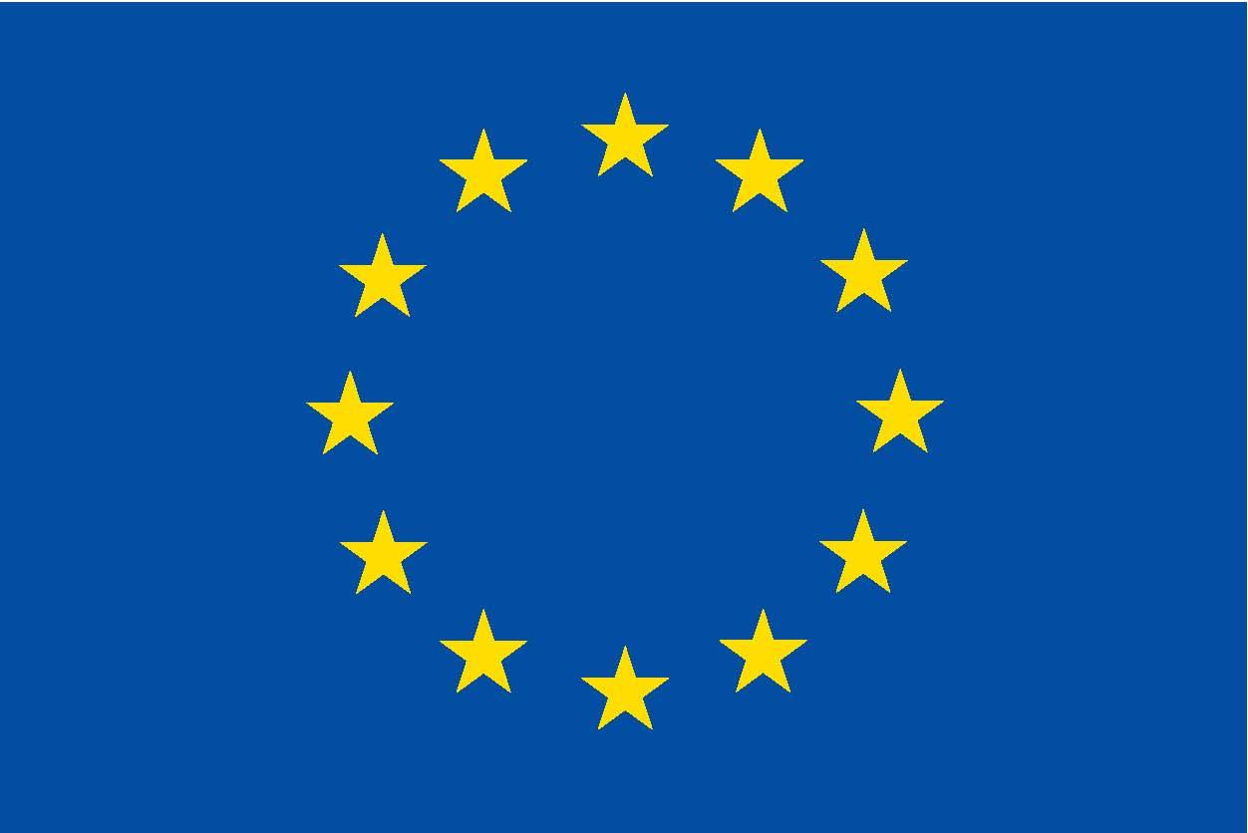

This school was renovated with the support

of the European Union

European Union

LOGO OF THE ACTION OR BENEFICIARY/PARTNER

Title of the beneficiary

or partner

Implemented within the framework of the European Neighbourhood Instrument