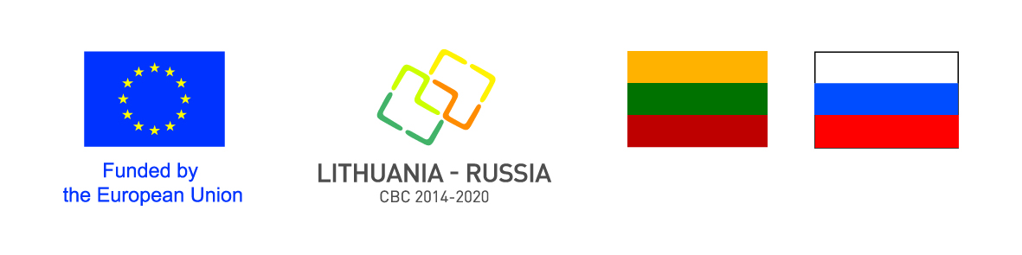

Lithuania-Russia
Cross-Border Cooperation Programme
2014-2020
EC Decision C(2016)8463

GRANT APPLICATION FORM
PART III
DECLARATION BY THE APPLICANT

The filled in Grant Application Form should be submitted to:
Joint Technical Secretariat
Konstitucijos pr. 7, LT-09308 Vilnius, Lithuania

DECLARATION BY THE APPLICANT

I, the undersigned, as representative of the <Official name of the organisation> applying for funding from the Lithuania–Russia Cross-Border Cooperation Programme 2014-2020 approved by the EC decision No.C(2016)8463 of 19 December 2016 (hereinafter – the Programme) as the Applicant of the Project <Title of the Project> hereby declare that:
- the Applicant possess sufficient human, financing and administrative capacity necessary for implementation of the proposed Project. In particular it will be able to maintain sufficient financial liquidity to finance activities of the Project until receipt of the interim and balance payments;
- the Applicant Itself and its partner(s) are not in any of the situations excluding them from participation in the contracts which are listed in Section 3.2.3 of the Guidelines for Applicants and Beneficiaties;
- furthermore, it is recognised and accepted that if the Applicant and its partners participate in spite of being in any of these situations, we may be excluded in accordance with Section 3.2.3 of the Guidelines for Applicants and Beneficiaries;
- the Applicant itself and its partner(s) are eligible in accordance with the set criteria;
- the Applicant is directly responsible for the management and implementation of the Project with its partners and is not acting as an intermediary;
- the Applicant and its partners shall fulfill the obligations to inform the general public about funding received from the Programme to implement the Project in compliance with Communication and Visibility Manual for EU External Actions and the Programme requirements;
- the Applicant undertakes to comply with the principles of good partnership practice, including:
a) to consult partners / beneficiaries regularly and keep them fully informed on the progress of the Project;
b) to send to beneficiaries copies of the reports made for the Managing Authority;
c) to agree with Beneficiaries on proposals for changes to the Project before submission to the Managing Authority. Where no such agreement can be reached, the Applicant/Lead Beneficiary must clearly indicate this fact when submitting changes for approval to the Managing Authority;
- the Applicant itself and its Partners have provided all the requested supporting documents and confirms that the information provided within the supporting documents is true and correct;
- the Applicant/Lead Beneficiary and the Partners/Beneficiaries do not receive or has not applied for any State aid or de minimis aid to finance the same costs and activities of the Project supported by the Programme;
- the proposed Project neither in whole nor in part has been financed by other EU programme or other donor programmes (to avoid double financing);
- the Project will be co-financed by the Applicant/Lead Beneficiary and the Beneficiaries from their own resources;
- the activities that will be carried out in the framework of the Project are in line with the European Union legislation and national legislation, as well as the Programme rules.
- the Applicant itself and its Partner(s) are aware that, for the purposes of safeguarding the financial interests of the EU, their personal data may be transferred to internal audit services, the European Court of Auditors, the Financial Irregularities Panel or the European Anti-Fraud Office. The Russian Federation and the Republic of Lithuania may conduct additional checks on the use of the Programme financing each on its respective territories.
- in case of signature of the Grant Contract with the Managing Authority the Applicant actings as Lead Beneficiary will assume full legal and financial responsibility for project implementation vis-à-vis that authority as Lead Beneficiary.
Moreover the Applicant by signing the Declaration declares that:
(Please tick off the relevant)

☐ Organisation is not entitled to recover any paid Value Added Tax (VAT) by whatever means, and therefore all the expenditure related to the Project to be reported will include VAT.
☐ Organisation is entitled to partially recover Value Added Tax (VAT) and all the expenditure related to the Project will only include non-recoverable VAT.

Signed on behalf of the Applicant:
Name and position of the signatory
Location
Date of signature
Signature and stamp (if applicable)

